

Name: Arkadiusz Grudzien

ID Number: 20001306

Date: Tuesday, 13 December 2022

Module leader: Ela

Supervisor: Victor Sowinski-Mydlarz

|  |  |
| --- | --- |
| |  | | --- | |  | |

Project

Report Interim

Submission

This report describes the process which will be used for creating the Crew Logistic System

**CS6P05 Project**

Contents

Declaration 2

Abstract 3

# Declaration

**PLAGIARISM**

You are reminded that there exist regulations concerning plagiarism. Extracts from these regulations are printed below. Please sign below to say that you have read and understand these extracts:

Student signature: Arkadiusz Grudzien Date: 13/12/22

This header sheet should be attached to the work you submit. No work will be accepted without it.

Extracts from University *Regulations* onCheating, Plagiarism and Collusion

Section 2.3: "The following broad types of offence can be identified and are provided as indicative examples…

1. Cheating: including taking unauthorised material into an examination; consulting unauthorised material outside the examination hall during the examination; obtaining an unseen examination paper in advance of the examination; copying from another examinee; using an unauthorised calculator during the examination or storing unauthorised material in the memory of a programmable calculator which is taken into the examination; copying coursework.
2. Falsifying data in experimental results.
3. Personation, where a substitute takes an examination or test on behalf of the candidate. Both candidate and substitute may be guilty of an offence under these Regulations.
4. Bribery or attempted bribery of a person thought to have some influence on the candidate's assessment.
5. Collusion to present joint work as the work solely of one individual.
6. Plagiarism, where the work or ideas of another are presented as the candidate's own.
7. Other conduct calculated to secure an advantage on assessment.

(viii) Assisting in any of the above.

Some notes on what this means for students:

1. Copying another student's work is an offence, whether from a copy on paper or from a computer file, and in whatever form the intellectual property being copied takes, including text, mathematical notation and computer programs.

2. Taking extracts from published sources *without attribution* is an offence. To quote ideas, sometimes using extracts, is generally to be encouraged. Quoting ideas is achieved by stating an author's argument and attributing it, perhaps by quoting, immediately in the text, his or her name and year of publication, e.g. "e = mc2 (Einstein 1905)". A *references* section at the end of your work should then list all such references in alphabetical order of authors' surnames. (There are variations on this referencing system which your tutors may prefer you to use.) If you wish to quote a paragraph or so from published work then indent the quotation on both left and right margins, using an italic font where practicable, and introduce the quotation with an attribution.

# Abstract

This project requires the development of a web-application system for the event company Pinnacle Crew. Pinnacle have been specializing in providing crew for corporate events. They have systems and tools in place for maintaining their business but are missing valuable features meaning they don’t currently have a system that can efficiently maintain organisation of the employed crew within their company. The system currently in use is a simple SMS system, which is not convenient from the crew's perspective. The current system functions in the following way: The admin (officer) sends an SMS to each crew member detailing: Job Number, Date, Time, Required Amount of Crew, Shift Duration, Client’s Company Name, Contact Number on site, Additional Notes. When the crew receive the message, the user must reply with 'YES' or 'NO' and supply the job number ID. The confirmation, if the crew member is assigned to the job, is called 'CREW LIST'. This is sent usually 24h before starting the job. The crew list consists of all the information about the job, phone numbers and names of all the members which they have been assigned to the specific job. The idea for the new system is to substitute the current inconvenient system to web-application where crew members can effectively communicate with the office about the jobs. The employers also will see the details about the jobs, their details etc.

# 1: Introduction

## 1.1 Project topic and rationale

The project topic is a web application called Crew Logistic System. The projects motivation is that I am working for the Pinnacle Crew. During work at the company, I have realized what are the problems. I have decided to develop a web application to solve the problems.

The software will be designed to help the company Pinnacle Crew to manage their crew members and jobs. The project is interesting because it is a real-life project, and it is a good opportunity to learn how to develop a web application. The problem in hands is that the company Pinnacle Crew is using a SMS system to manage their crew members and jobs. The jobs are events that the companies of events are organizing, and the crew members are the people that are working on the events. The admin sends jobs to specific crew members. The crew members must confirm or reject by doing specific action in the app. The usefulness of the app is that it will help the company to manage their crew members and jobs more efficiently.

# Chapter 2 Background Research

My project called Crew Logistic System is going to be from like already created systems such as:

* Employee Management Software
* Employee Logistic Solutions
* Employee Logistic System
* Product Logistic System
* Human Resource Management (Write about each of it. Find a proper source)

The list above will help me to understand and create the project. I must do proper research about each of this list and find at least one example of those systems.

## 2.1 Literature review of related work

**Employee Management System**

The first similar type of system to mine is Employee Management System. This type of system is challenging task to develop especially if it’s about using it remotely. The employee management system gives efficient way to manage work between admin work and the team. The system is designed to help the business owner specially to save money and time. The system can help for example what kind of task does specific worker. The admin via the system can assign to different assignment or/and department. The worker can efficiently apply for a holiday and the admin can accept it or reject it. The employees can add work report. Employee also can send a leave request so the employer will know this information immediately and will start to look for a substitution.

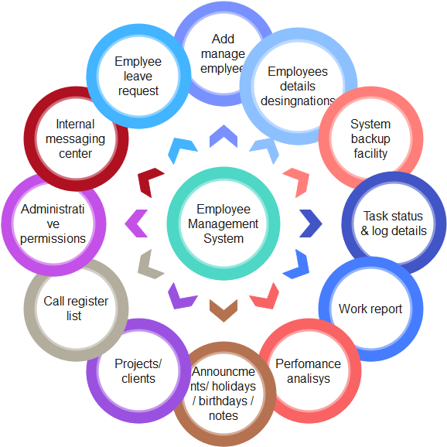The Employee Management System is very important for the business where it runs. The data which is store in database can be accessed just for the authorized personnel with specific permissions. This is one of many important aspects during developing such as system. The system allows to have the data from the origin source which means from the employee because he/she can update the details about their self. The system provides a quick information for the admin and especially for the worker. The worker can see the work schedule, salary information, education information or contact information. This data is very useful because it allows to improve the efficiency and workflow of the business. Based on these data the admin or head of the organization can assign or reassign the specific tasks or departments or adjust the salary and the work schedule etc. (Diawati, Prety & Paramarta, Vip & Pitoyo, Djoko & Fitrio, Tomy & Mahrani, Wiyati 2019).

Figure Example of functions for Employee Management System

Designing the Employee Management System

Very Useful Article at III section : Proposed System

[Employee Management System](https://d1wqtxts1xzle7.cloudfront.net/59920839/IRJET-V6I53820190703-77340-1wgivtj-libre.pdf?1562151693=&response-content-disposition=inline%3B+filename%3DIRJET_Employee_Management_System.pdf&Expires=1670978160&Signature=Gw55YsNjagwIsUj7WUcia4zOU6mLk5odloa7hTg3gGdHJt99nPaUwiy5B~r8zdJjlEPR9cTJWL8G~PKwi6K5keGOpZcj2hKctJnD4bftQL-Ee-no25ZEw4RhuOmy8gMorQaLC2YwR0Nz3F5MuKXBW0saDqN5bdxtdGUuyQD9bvvYZLvhF6YDLo3NUcRP6QCWGyHp~s4WtuL7OLzpVkFab~4lUD0ETquoHRsFd2MukhHA82XlCv6OqCLbAi~DLIGnoLa-DiMZfzlLamQIfwVZjq-JqBg~MHQ-ApX1S3obiV0frI~IAkPyrXrBv2u3HVsYHlp~ocXvbHPoi4-02pUIjA__&Key-Pair-Id=APKAJLOHF5GGSLRBV4ZA)

## 2.2 Critical evaluation of related products/solutions

<https://github.com/Vishalsvisual/Spring-Boot-ReactJs.git>

Allready developed similar software like this project

SMB –

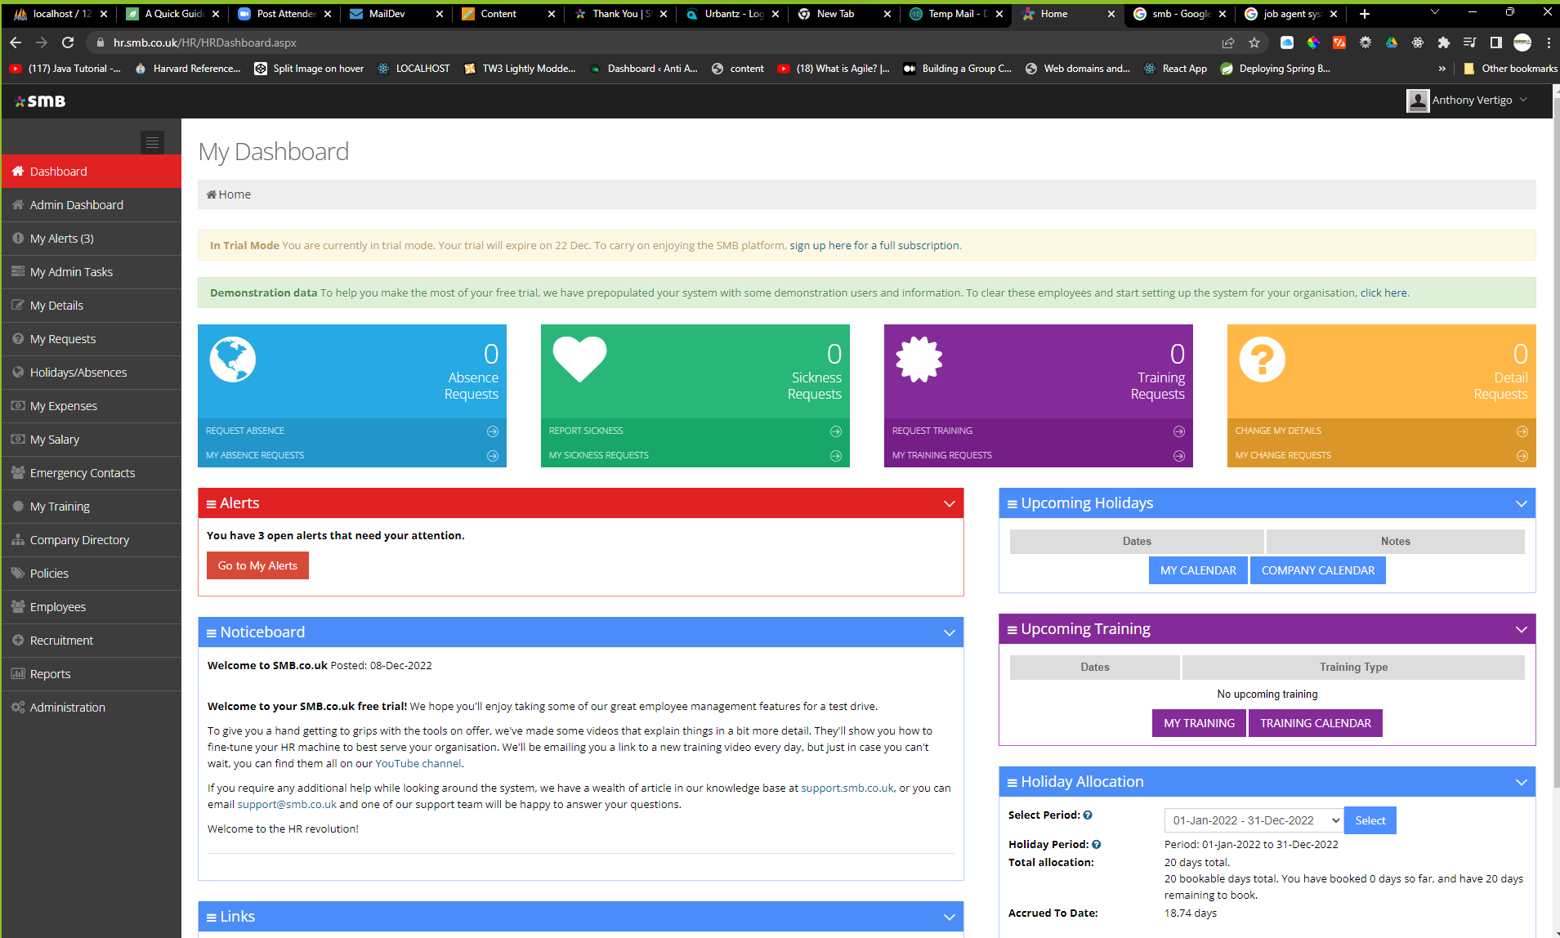

https://hr.smb.co.uk/HR/HRAdminDashboard.aspx

Steps to designing good database

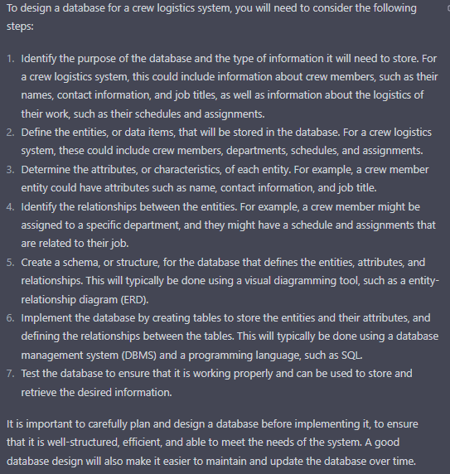

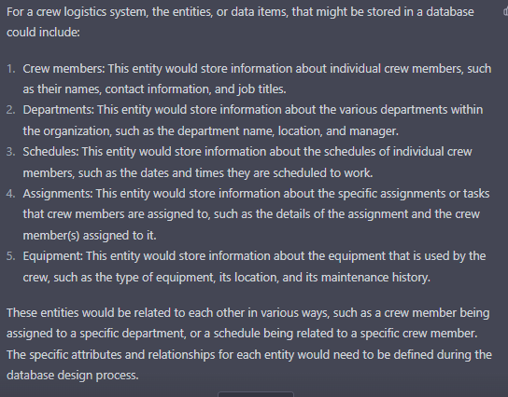

# References

Diawati, Prety & Paramarta, Vip & Pitoyo, Djoko & Fitrio, Tomy & Mahrani, Wiyati. (2019). Challenges of Implementing an Employee Management System for Improving Workplace Management Effectiveness. Available at <https://www.researchgate.net/profile/Tomy-Fitrio/publication/338216184_Challenges_of_Implementing_an_Employee_Management_System_for_Improving_Workplace_Management_Effectiveness/links/5e07f14a4585159aa4a25ba6/Challenges-of-Implementing-an-Employee-Management-System-for-Improving-Workplace-Management-Effectiveness.pdf> . Last accessed 13 December 2022